ExpenseFlow
AI powered personal expense tracker
Problem statement:
Analyzes uploaded receipts or bank statement images, extracts transaction details, and categorizes expenses to present a clear spending summary.

Understanding the problem statement:
To create an AI based solution for tracking the personal expense of the user to manage the financial expenses and provide detailed information about the top expenses, the income of the user and about what their investments are and how much they are saving to increase their financial status.

Solution given:
- Converted image input to a Pandas DataFrame for analysis
- The description from the bank statement and categorize them as income, expenses (food, travel, entertainment, etc..), investment and savings
- Analyze the top and bottom 5 expenses
- Comparing the income with the expense using charts
- Visualizing the expenses with its category to know where the user is spending more
- Providing overview of the income, expense, investment and savings
- Summary about their financial health and suggestions to improve their financial wealth
- AI chatbot to clarify the user’s doubts and queries about the analyzed data

Techs used:
- Frontend: Next.js
- Backend: Python, FastAPI
- Models: Gemma-4 26b and Gemini-3.1-flash-lite-preview
Folder structure:
personal_expense_tracker/
├── backend/
│ ├── api/
│ │ └── main.py # FastAPI application entry point
│ ├── analysis/
│ │ ├── chatbot.py # AI Chatbot logic
│ │ ├── expense_analyzer.py # Expense analysis & visualization
│ │ └── expense_summarizer.py # Summary generation logic
│ ├── categorizer/
│ │ ├── categorize_transaction.py # Transaction type
│ │ ├── categorizer.py # Transaction classification
│ │ └── data_combiner.py # Data processing utilities
│ ├── input/
│ └── image_to_df.py # Converts image input to DataFrame
│ ├── app.py # Alternative StreamLit UI
│ └── requirements.txt # Python dependencies
└── frontend/
├── src/components/
│ ├── AnalyticsCards.tsx # Visualization components
│ ├── ChatInterface.tsx # AI Assistant UI
│ ├── ExpenseTable.tsx # Transaction list view
│ └── UploadZone.tsx # File upload drag-and-drop
└── package.json # Node.js dependencies & scripts
Architecture:
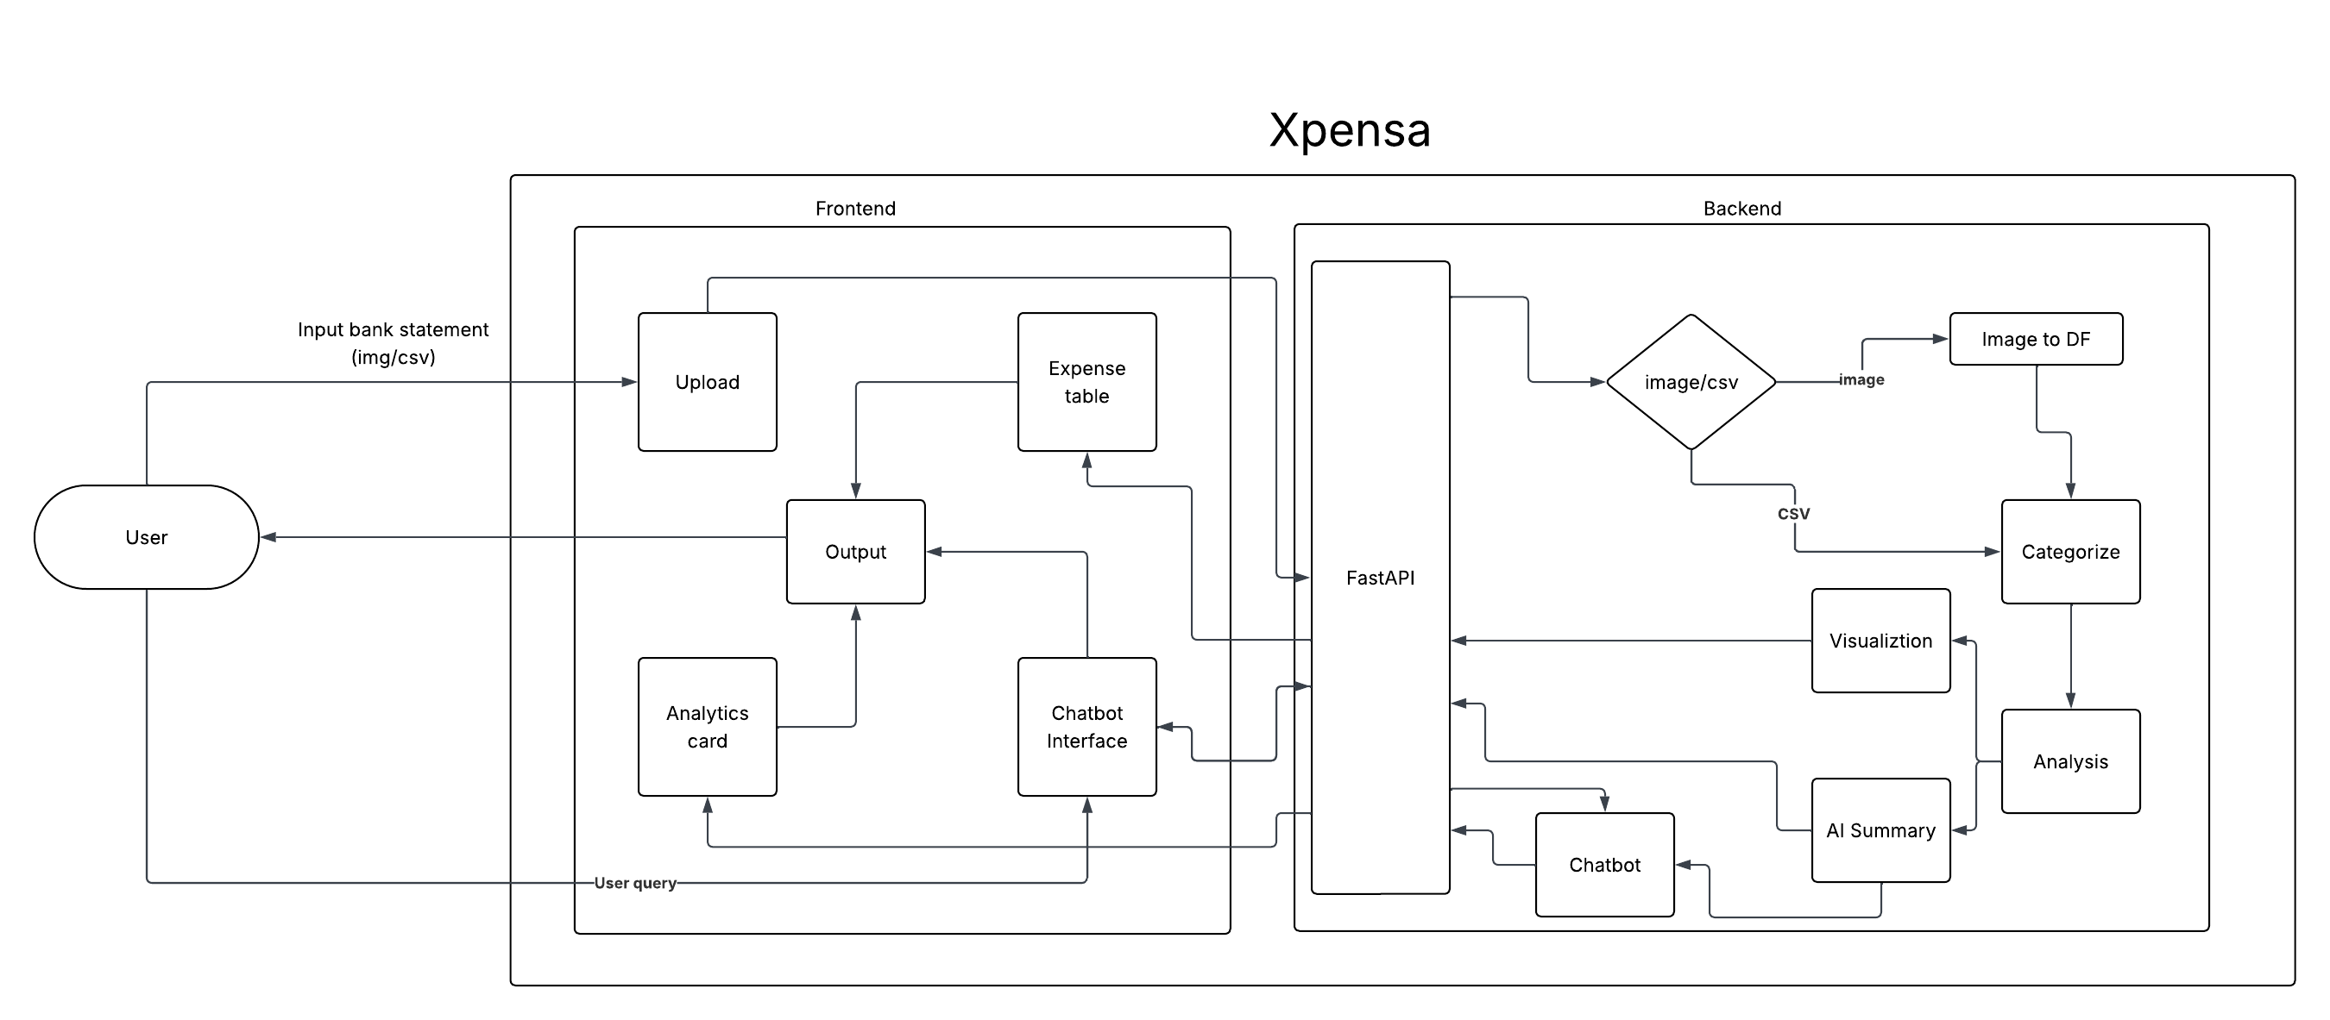

Challenges:
- Implementation of Next.js with Python as backend using FastAPI
- Can’t add more features because of the simplicity of the problem statement
- Initially used OpenCV for text recognition but it is harder to detect

Future enhancements:
- User authentication
- Adding a database to make it as finance advisor

